School of Engineering, Applied Sciences, and Technology

BCS 202 Introduction to Computer Science II
SWS 316 Programming II

Project

Course Learning Outcomes | Project
CLO1. Demonstrate knowledge of the principles of Object-Oriented Programming | X | Q&A
CLO2: Apply the concepts of inheritance, polymorphism, interfaces and abstract classes to build efficient, muli-class applications.
CLO3: Code robust programs involving different data structures and exception handling constructs. | X | Code & Report
CLO4: Implement programs involving different data streams and file I/O.

Team Members
ID | Student Name | Q&A / 10 | Code & Report / 10 | Total / 20
20220002112 | Masa Dkak
20210002264 | Hamdan Habib
20210001983 | Leanne Jessica Rodrigo
20220002458 | Aysha Ejaz

Project Description and Requirements
You are asked to implement the below tasks, attach the code, and the screen shots that prove that your solution cover all test cases.

Submission Instructions
- This is a group-based assignment (max of 5 members).
- The project consists of two parts: Coding & Reporting part and Q&A session.
- Choose only one project to implement.
- Coding & Reporting Part:
  - Your code should work.
  - It should contain embedded comments.
  - You should cover all test cases in the report.
  - You should provide screenshots of the output.
- Q&A Part:
  - Each student, with his/her laptop, will be asked individually.
  - The questions cover theory and practice of the project.
- Use this template for your final submission. Fill out the names of students on the front page.
- Attach your report to the end of this document (copy and paste).

Project Description
For this project, students are encouraged to develop their own unique Java application, demonstrating their creativity and problem-solving skills. The application should address a specific problem or cater to a particular need within any domain of their choice, such as finance, healthcare, education, entertainment, or social networking. The project must incorporate the following key concepts:
- Java Basics, Arrays, and Strings:
  - Utilize arrays and strings for efficient data handling and manipulation within the application.
- Classes, Inheritance, Abstraction, and Interfaces:
  - Design classes with appropriate attributes and methods. Implement inheritance, abstraction, and interfaces where applicable to enhance the application's structure and flexibility.
- Exception Handling:
  - Implement robust exception handling mechanisms to handle errors gracefully and ensure a seamless user experience.
- File Handling:
  - Utilize file handling techniques to persistently store and retrieve data, allowing the application to maintain user information or application states across sessions.

Project Requirements:
- Innovative Concept: Choose an innovative and practical concept for the application. The idea should demonstrate the student's creativity and problem-solving abilities.
- Functionality: Implement core features relevant to the chosen domain. This could involve user interactions, data processing, calculations, simulations, or any other functionality that adds value to the application.
- User Interface (console): Design an intuitive and user-friendly interface if the application involves user interactions. Consider usability, aesthetics, and user experience to enhance the application's appeal.
- Exception Handling: Implement comprehensive error handling mechanisms to anticipate and manage unexpected scenarios, ensuring the application's stability and user satisfaction.
- File Handling: Implement file handling to store and retrieve data persistently. This could include user preferences, application settings, or any other relevant information crucial for the application's functionality.

Project 4: Inventory Management System

Project Description:
In this project, students will create an Inventory Management System using Java. The system should allow users to add products, update product details, track inventory levels, and generate reports. The project must incorporate Java basics, arrays, strings, classes, inheritance, abstraction, interfaces, exception handling, and file handling concepts.

Project Requirements:
- Implement classes for products and inventory management.
- Allow users to add new products, update product details, and adjust inventory levels.
- Display product details, current inventory levels, and low stock alerts.
- Generate a report with product names, quantities sold, and revenue.
- Store product data and transaction history using file handling.

Requirements:
- Functionality
  - Proper implementation of product addition, updating, inventory tracking, report generation, and low stock alerts functionality.
  - Correct handling of exceptions and input validation.
  - Effective use of file handling for data storage and retrieval.
- Object-Oriented Concepts
  - Proper use of classes, inheritance, abstraction, and interfaces.
  - Clear organization of code and separation of concerns.
- User Interface and Experience
  - User-friendly interface with clear prompts and instructions.
  - Intuitive user interactions for tasks like product addition, updating, and report generation.
- Code Quality and Readability
  - Consistent coding style, proper indentation, and meaningful variable/method names.
  - Comments and documentation explaining complex logic or algorithms.

UML DIAGRAM

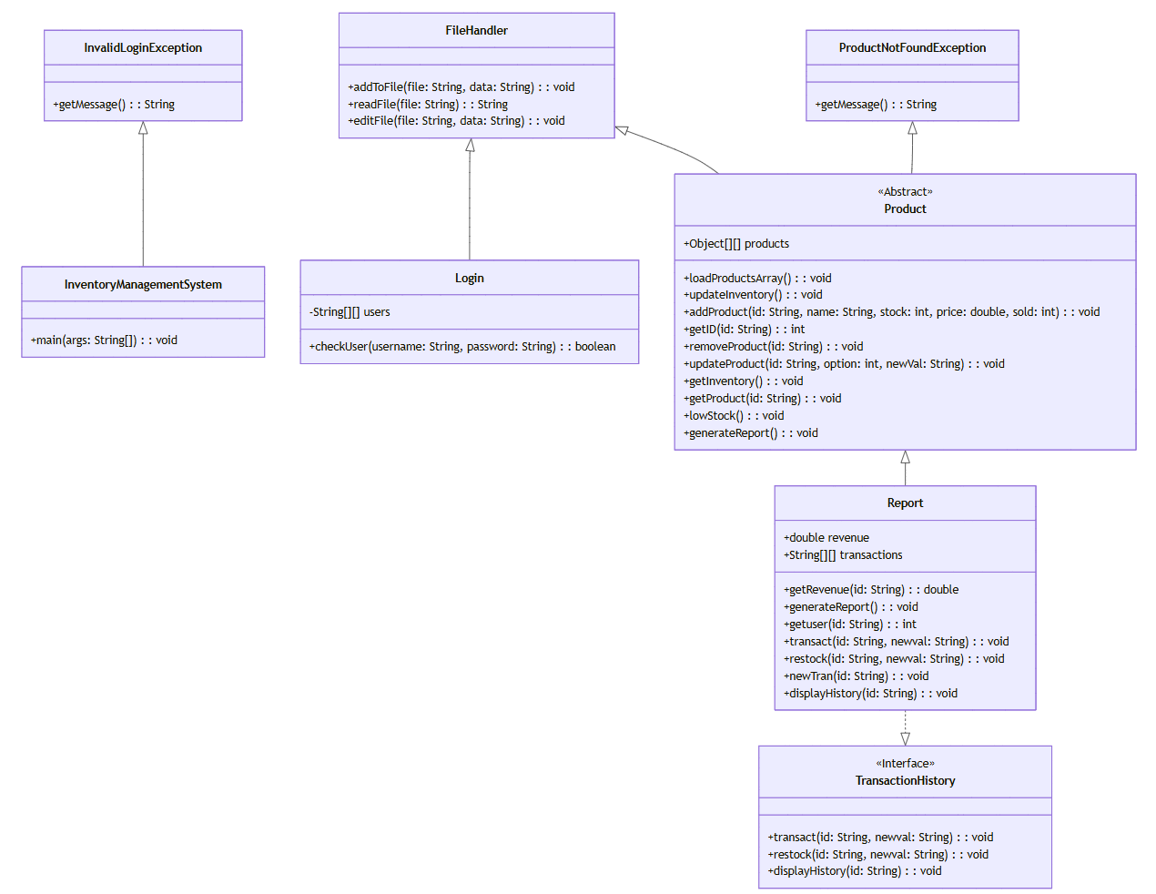

CODE

FileHandler class

import java.io.File;

import java.io.FileWriter;

import java.io.IOException;

import java.io.FileNotFoundException;

import java.util.Scanner;

public class FileHandler {

public static void addToFile(String file, String data) throws Exception {

try {

File f1 = new File(file);

if (f1.exists()) {

FileWriter myWriter = new FileWriter(file,true);

myWriter.write(data);

myWriter.close();

}

else{

throw new FileNotFoundException();

}

} catch (FileNotFoundException f) {

System.out.println("file does not exist.");

} catch (IOException ioe) {

System.out.println(ioe.getMessage());

} catch (Exception e) {

System.out.println("an error occurred.");

}

}

public static String readFile(String file) throws Exception {

try{

File f2 = new File(file);

Scanner reader = new Scanner(f2);

String data = "";

while (reader.hasNextLine()){

String line = reader.nextLine();

data+=line + "\n";

}

reader.close();

return data;

} catch (FileNotFoundException f){

return "file not found.";

}

}

public static void editFile(String file, String data) throws Exception{

try {

File f1 = new File(file);

if (f1.exists()) {

FileWriter myEditor = new FileWriter(file);

myEditor.write(data);

myEditor.close();

}

else{

throw new FileNotFoundException();

}

} catch (FileNotFoundException f) {

System.out.println("file does not exist.");

} catch (IOException ioe) {

System.out.println(ioe.getMessage());

} catch (Exception e) {

System.out.println("an error occurred.");

}

}

}

Login Class

public class Login extends FileHandler {

private static String[][] users;

public static boolean checkUser(String username, String password) throws Exception{

String data = readFile("user.txt");

String[] lines = data.split("\n");

users = new String[lines.length][2];

for(int i=0; i< lines.length; i++){

if ( !lines[i].isEmpty() ) {

users[i] = lines[i].split(",");

}

}

for (int i = 0; i< users.length; i++){

if (users[i][0].equals(username) && users[i][1].equals(password)) {

return true; // Login successful

}

}

return false;

}

}

Product Class

public abstract class Product extends FileHandler {

public static Object[][] products;

public static void loadProductsArray() throws Exception {

String data = readFile("inventory.txt");

String[] lines = data.split("\n");

products = new Object[lines.length][5];

for (int i = 0; i < lines.length; i++) {

String[] columns = lines[i].split(",");

products[i][0] = columns[0];

products[i][1] = columns[1];

products[i][2] = Integer.parseInt(columns[2]);

products[i][3] = Double.parseDouble(columns[3]);

products[i][4] = Integer.parseInt(columns[4]);

}

}

public static void updateInventory() throws Exception {

String data = "";

for (int i = 0; i < products.length; i++) {

for (int k = 0; k < products[i].length; k++) {

data += products[i][k];

if (k < products[i].length - 1) {

data += ",";

}

}

data += "\n";

}

FileHandler.editFile("inventory.txt", data);

}

public static void addProduct(String id, String name, int stock, double price, int sold) throws Exception {

int rows = products.length + 1;

Object[][] newProducts = new Object[rows][5];

int j = 0;

for (int i = 0; i < products.length; i++) {

newProducts[j] = products[i];

j++;

}

Object[] newProd = { id, name, stock, price, sold };

newProducts[rows - 1] = newProd;

products = newProducts;

updateInventory();

Report t = new Report();

t.newTran(id);

}

public static int getID(String id) throws ProductNotFoundException {

try {

int index = -1;

for (int i = 0; i < products.length; i++) {

if (products[i][0].equals(id)) {

index = i;

break;

}

}

if (index == -1) {

throw new ProductNotFoundException();

}

return index;

} catch (ProductNotFoundException p) {

System.out.println(p.getMessage());

return -1;

}

}

public static void removeProduct(String id) throws Exception {

int index = getID(id);

Object[][] newProducts = new Object[products.length - 1][5];

int j = 0;

for (int i = 0; i < products.length; i++) {

if (i != index) {

newProducts[j] = products[i];

j++;

}

}

products = newProducts;

updateInventory();

}

public static void updateProduct(String id, int option, String newVal) throws Exception {

int index = getID(id);

switch (option) {

case 1:

products[index][0] = newVal;

break;

case 2:

products[index][1] = newVal;

break;

case 3:

products[index][2] = (Integer) products[index][2] + Integer.parseInt(newVal);

Report t1 = new Report();

t1.restock(id, newVal);

break;

case 4:

products[index][3] = Double.parseDouble(newVal);

break;

case 5:

products[index][4] = (Integer) products[index][4] - Integer.parseInt(newVal);

products[index][2] = (Integer) products[index][2] - Integer.parseInt(newVal);

Report t2 = new Report();

t2.transact(id, newVal);

break;

default:

System.out.println("Invalid option.");

break;

}

updateInventory();

}

public static void getInventory() {

System.out.println("PRODUCT: INVENTORY LEVEL");

for (int i = 0; i < products.length; i++) {

System.out.println(products[i][1] + " : " + products[i][2]);

}

}

public static void getProduct(String id) throws Exception {

int index = getID(id);

System.out.println("ID: "+products[index][0]+"\nName: "+products[index][1]+"\nStock: "+

products[index][2]+"\nPrice: "+products[index][3]+"\nSold:"+products[index][4]);

}

public static void lowStock() {

System.out.println("low stock products:");

for (int i = 0; i < products.length; i++) {

String name = (String) products[i][1];

int stock = (int) products[i][2];

if (stock < 100) {

System.out.println(name + " : " + stock);

}

}

}

abstract void generateReport() throws Exception;

}

TransactionHistory Class

public interface TransactionHistory {

public void transact(String id, String newval) throws Exception;

public void restock(String id, String newval) throws Exception;

public void displayHistory(String id) throws Exception;

}

Report Class

public class Report extends Product implements TransactionHistory {

double revenue;

public static String[][] transactions = {

{"p10001","+5,-2,+7"},

{"p10002","+10,-5,-1,+3"},

{"p10003","+5,-2,+7"},

{"p10004","+10,-5,-1,+3"}};

public double getRevenue(String id) throws Exception {

int index = getID(id);

double price = (double) products[index][3];

int sold = (int) products[index][4];

revenue = price * -sold;

return revenue;

}

@Override

public void generateReport() throws Exception {

System.out.println("\n ===== PRODUCT REPORT =====");

System.out.println("\nID, NAME, STOCK, PRICE, SOLD, REVENUE");

for (int i = 0; i < products.length; i++) {

String id = (String) products[i][0];

String name = (String) products[i][1];

int stock = (int) products[i][2];

double price = (double) products[i][3];

int sold = (int) products[i][4];

double revenue = (double) getRevenue(id);

String line = id + ", " + name + ", " + stock + ", " + price + ", " + -sold + ", " + revenue;

System.out.println(line);

}

System.out.println("\n =============================");

}

public int getuser(String id) throws ProductNotFoundException {

try {

int index = -1;

for (int i = 0; i < transactions.length; i++) {

if (transactions[i][0].equals(id)) {

index = i;

break;

}

}

if (index == -1) {

throw new ProductNotFoundException();

}

return index;

} catch (ProductNotFoundException p) {

System.out.println(p.getMessage());

return -1;

}

}

@Override

public void transact(String id,String newval) throws Exception {

int index = getuser(id);

transactions[index][1]=transactions[index][1]+ ",-" + newval;

}

@Override

public void restock(String id, String newval) throws Exception {

int index = getuser(id);

transactions[index][1]=transactions[index][1]+ ",+" + newval;

}

public void newTran(String id){

int rows = transactions.length + 1;

String[][] newT = new String[rows][2];

int j = 0;

for (int i = 0; i < transactions.length; i++) {

newT[j] = transactions[i];

j++;

}

String[] newProd = {id,"0"};

newT[rows-1] = newProd;

transactions = newT;

}

@Override

public void displayHistory(String id) throws Exception {

int index = getuser(id);

String line = transactions[index][1];

System.out.println("Transactions: " + line);

}

}

Exception Classes

public class InvalidLoginException extends Exception{

@Override

public String getMessage() {

return "error: Wrong username or password.";

}

}

public class ProductNotFoundException extends Exception {

@Override

public String getMessage() {

return "error: the product you are searching for does not exist.";

}

}

Main Class

import java.util.InputMismatchException;

import java.util.Scanner;

public class InventoryManagementSystem {

public static void main(String[] args) throws Exception {

Product.loadProductsArray();

Scanner input = new Scanner(System.in);

System.out.println("enter username: ");

String user = input.nextLine();

System.out.println("enter password: ");

String pass = input.nextLine();

try{

if (Login.checkUser(user,pass) ) {

System.out.println("Successfully logged in.");

boolean cont = true;

while (cont) {

System.out.println("\n\n");

System.out.println("WELCOME\nEnter your choice number:\n1.Add product\n2.Remove Product\n"+

"3.Update product.\n4.Display Inventory level\n5.Generate Report\n6.Product detail\n"+

"7.Low Stock Products\n8.display transactions\n9.EXIT");

int choice = input.nextInt();

input.nextLine();

switch (choice){

case 1:

System.out.println("enter product ID: ");

String id = input.nextLine();

System.out.println("enter product name: ");

String name = input.nextLine();

System.out.println("enter stock available: ");

int stock = input.nextInt();

System.out.println("enter product price: ");

double price = input.nextDouble();

input.nextLine();

Product.addProduct(id,name,stock,price,0);

System.out.println("Product added successfully.");

break;

case 2:

System.out.println("enter Product ID:");

String pID = input.nextLine();

Product.removeProduct(pID);

System.out.println("Product removed successfully.");

break;

case 3:

System.out.println("enter Product ID:");

String prd = input.nextLine();

System.out.println("What do you want to update? Choose Number:\n"+

"1.Product ID\n2.Product Name\n3.add to Stock\n4.Product Price\n5.Process Sale\n");

int option = input.nextInt();

input.nextLine();

System.out.println("enter value: ");

String newVal = input.nextLine();

Product.updateProduct(prd, option, newVal);

System.out.println("Product updated successfully.");

break;

case 4:

Product.getInventory();

break;

case 5:

Report r1 = new Report();

r1.generateReport();

break;

case 6:

System.out.println("enter product ID: ");

String prod = input.nextLine();

System.out.println("Product detail: ");

Product.getProduct(prod);

break;

case 7:

Product.lowStock();

break;

case 8:

Report transactions = new Report();

System.out.println("enter product ID: ");

String tranID = input.nextLine();

transactions.displayHistory(tranID);

break;

case 9:

System.out.println("PROGRAM EXITED.");

cont = false;

break;

default:

System.out.println("Invalid number.");

break;

}

}

input.close();

}

else{

input.close();

throw new InvalidLoginException();

}

} catch(InvalidLoginException l){

System.out.println(l.getMessage());

} catch (InputMismatchException i) {

System.out.println("error: the entered input is of wrong type.");

} catch (Exception e) {

System.out.println("Sorry! an error occured.");

}

}

}

Text Files:

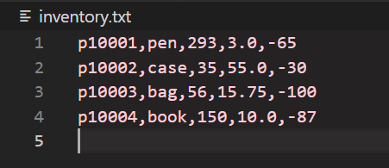

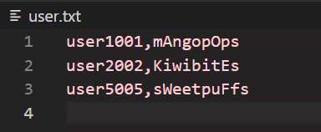

Code Testing

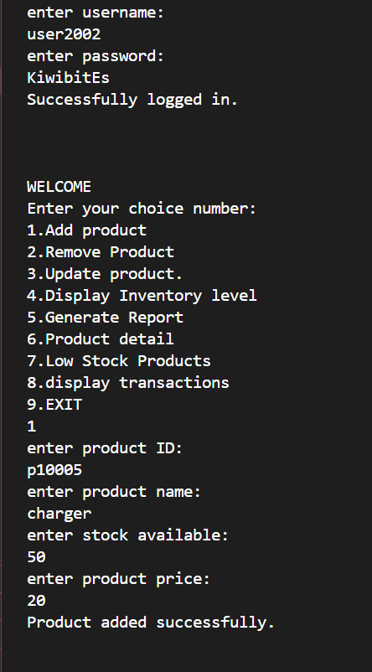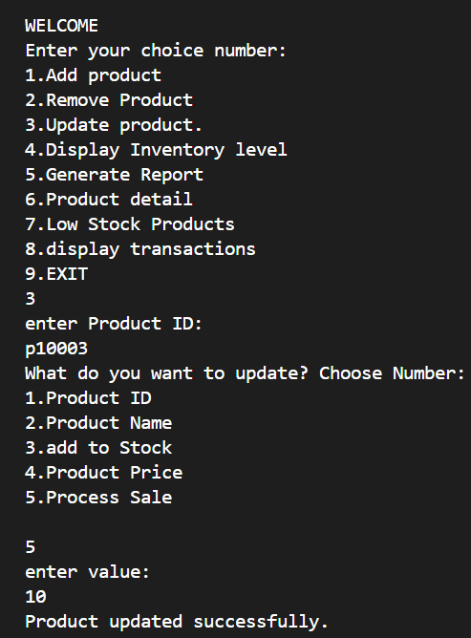

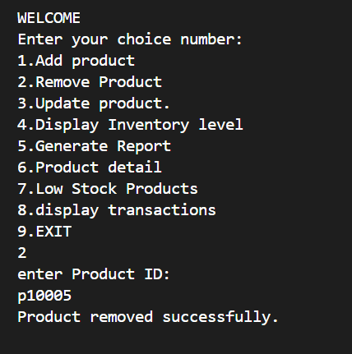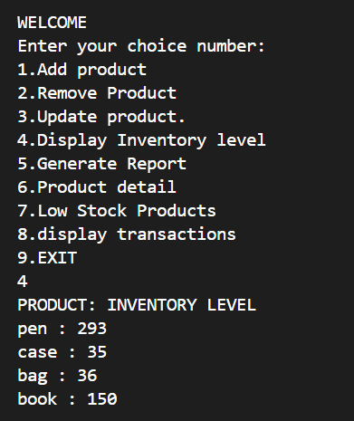

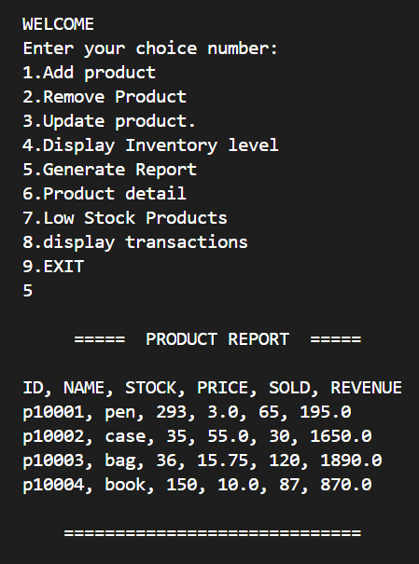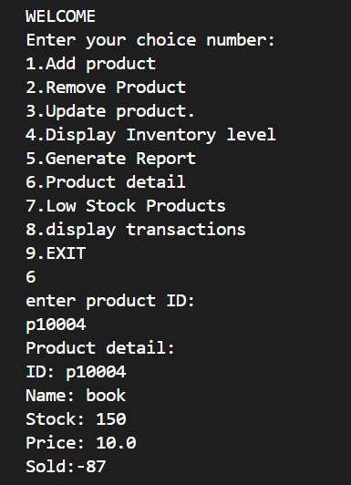

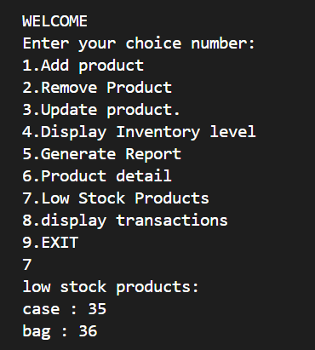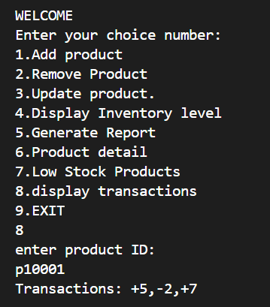

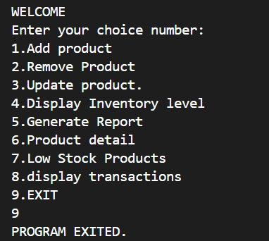

Report

In order to track and manage products in a retail or storage setting, this Java application builds an inventory management system. In addition to preserving transaction histories and producing reports, the system manages features including adding, deleting, updating, and viewing product details. For safe access, the code additionally incorporates login functionality.

Main Class: Inventory Management System

serves as the program's entry point, allowing command-line interface user interaction. In order to carry out the necessary operations, it authenticates the user, presents alternatives, and interprets user input. It asks for a username and password and validates them using the login class. It displays a menu system which displays options for inventory management tasks and takes user input to call specific methods from the other classes.

Product Class

product class is an abstract class and the purpose of it is to Implement essential inventory-related features and maintains product data.
loadProductsArray: Loads product information into a 2D array by reading it from a file (inventory.txt).
addProduct: Updates the file and adds a new product to the inventory.
removeProduct: Updates the inventory and eliminates a product based on its ID.
updateProduct: Modifies the product's name, price, stock, and other details.
getInventory: Shows each product's inventory levels.
getProduct: Uses an ID to retrieve and show information about a particular product.
Products with stock levels below a threshold (such as 100 units) are identified and listed using lowStock.

Report Class

Extends Product and implements TransactionHistory.
The purpose is to manage transaction history and produce reports.
generateReport: Produces and shows a summary report that includes revenue figures for every product.
transact: Records a product's sales transactions.
restock: Records transactions related to replenishing.
displayHistory: Provides a product's transaction history.

Login Class

The goal of the login class is to enable user authentication by comparing login credentials to a file (user.txt).
The key method is to checkUser: Verifies that the password and username given match any entries in the user.txt file.

FileHandler Class
readFile: Reads a given file's contents.
editFile: Adds new information to a file.
addToFile: Adds new information to an already-existing file.

Transaction History Class

The purpose of the Transaction history interface is to specify how sales and restocking transactions should be handled.
transact: Documents a purchase.
Restock: Documents inventory replenishment.
displayHistory: Shows the history of transactions.

Particular Exceptions
When a given product ID is not present in the inventory, the ProductNotFoundException is raised.
When a user inputs incorrect login information, an InvalidLoginException is raised.

